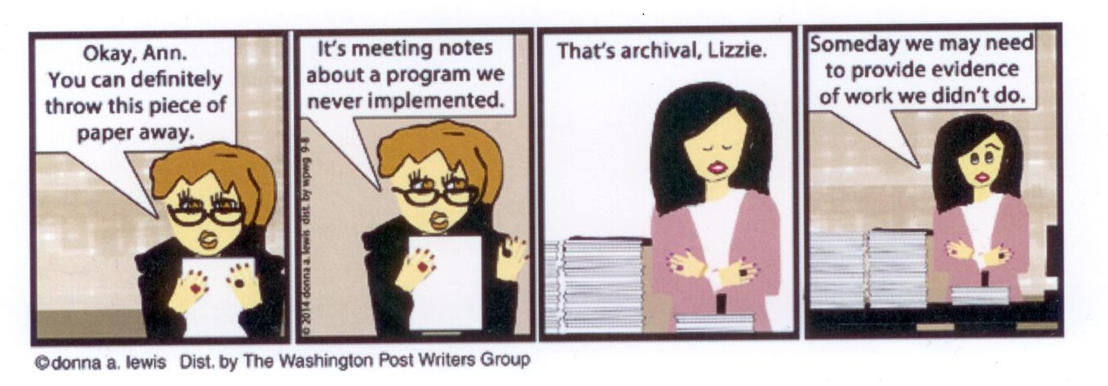

**Okay, Ann. Its meeting notes Thats archival, Lizzie. Someday we may need You can definitely about a program we to provide evidence throw this piece of never implemented. of work we didnt do.**

**paper away.**

©donna a lewis Dist, by The Washington Postwriters Group